**Lab W05 Class Practice Report**

Course Code - Course Name: - COMP4040 – Introduction to SOC

Program: T433 - Cybersecurity

Term: - Winter 2024

Group: SOC1-L2G- 11

Student Names - ID:

* Prabhjot Singh Sains – 101495218

We ran test scenarios on our Linux virtual machine connected to our SumoLogic account.

We tested the following credentials:

1. Valid users and passwords

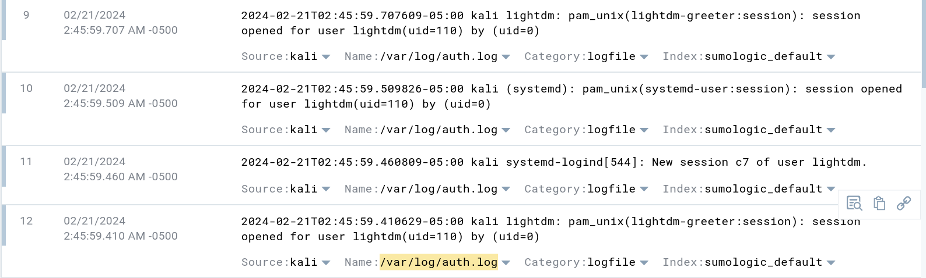

1. Valid users but incorrect passwords

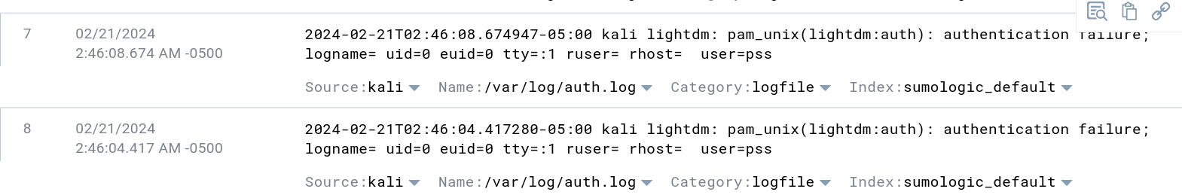

1. Invalid users

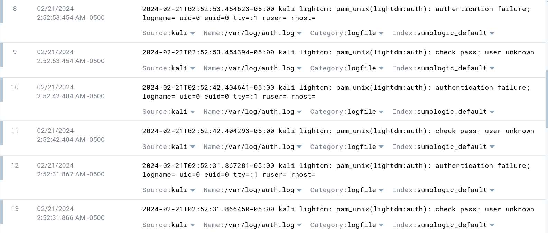

After performing the above tests, we create queries in SumoLogic to count the following in the last 60 minutes:

1. The number of failed logins

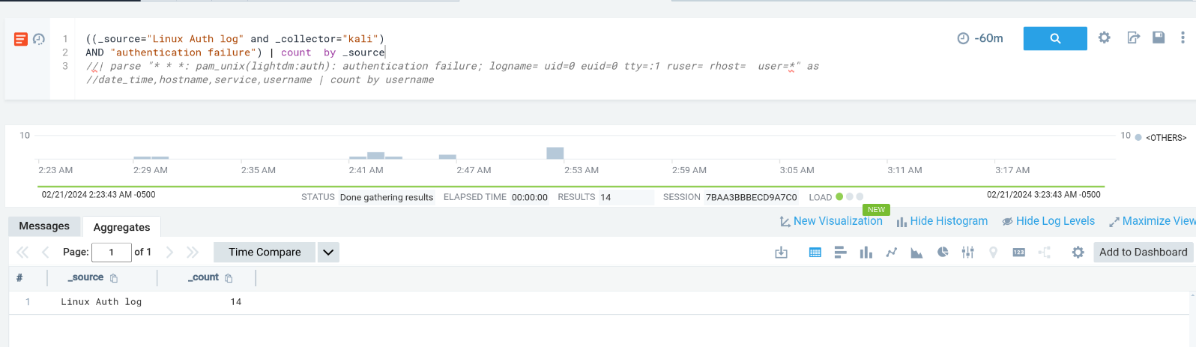

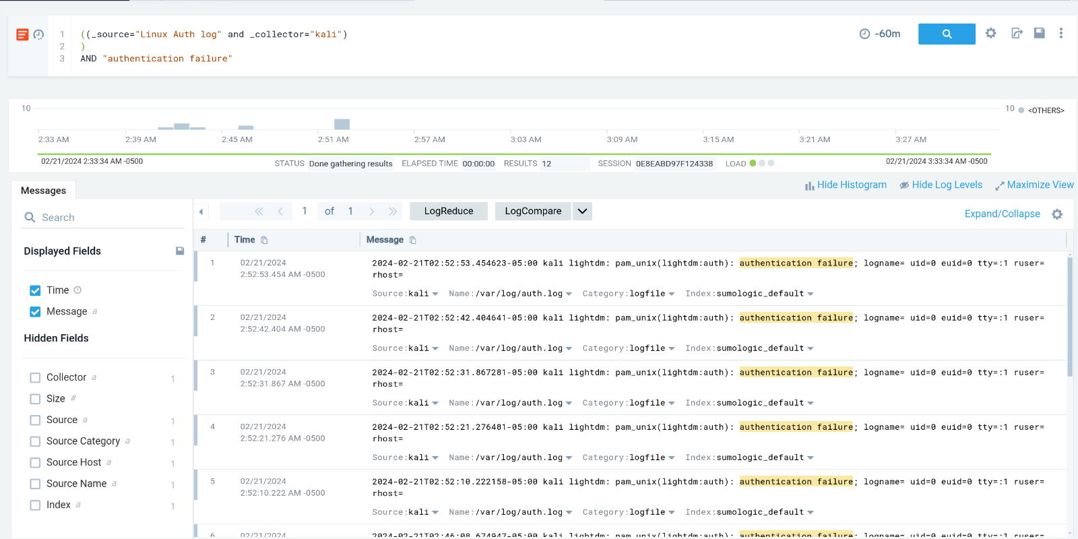

1. The number of successful logins

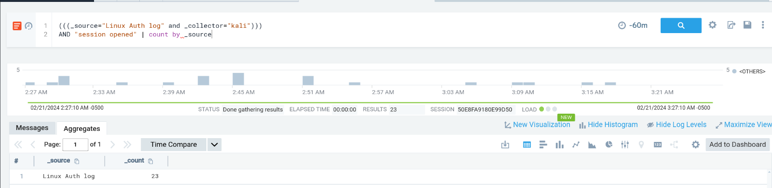

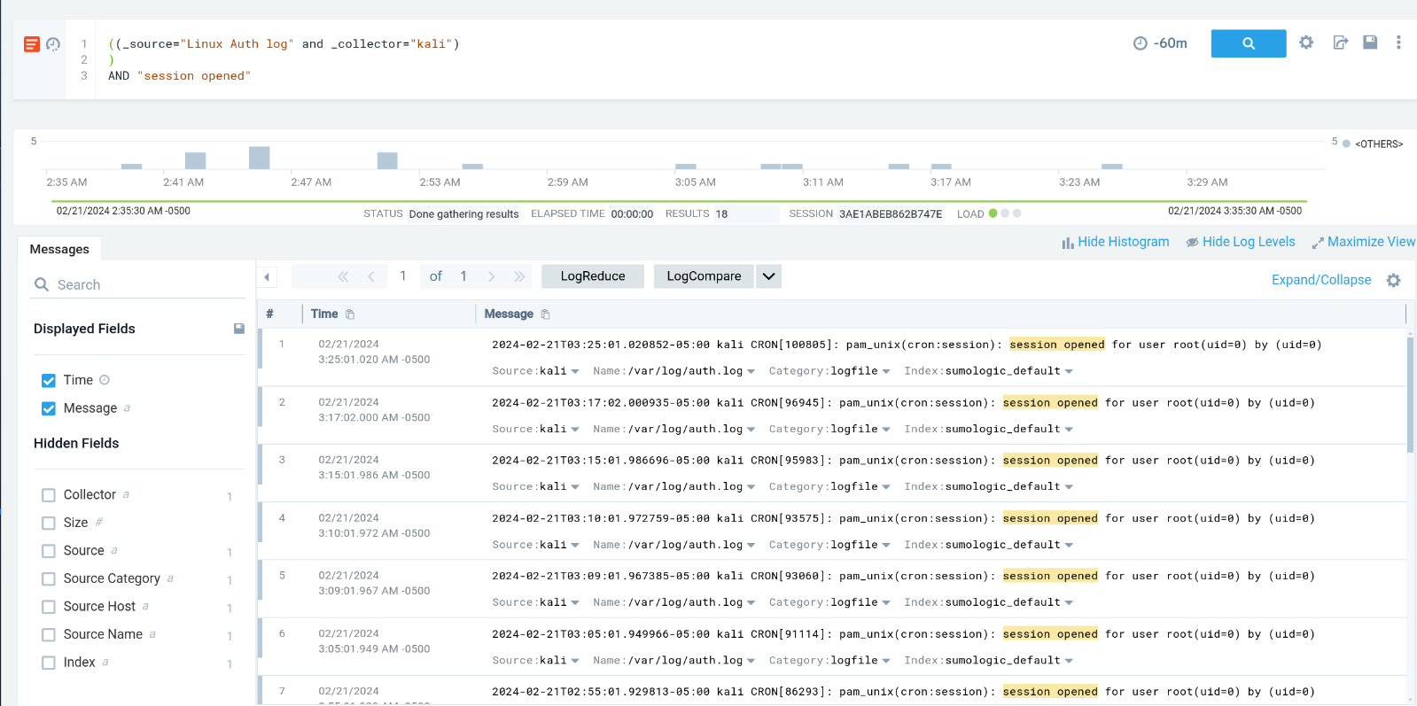

1. The number of invalid users

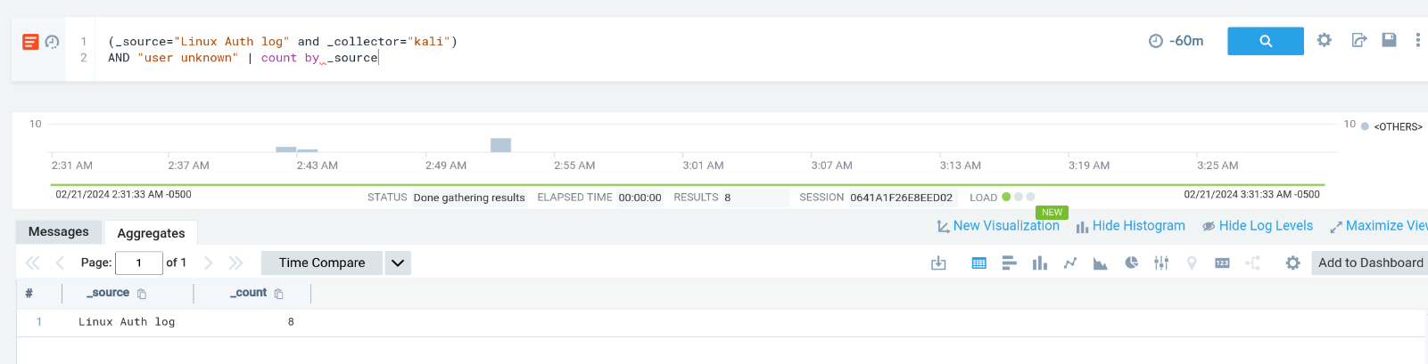

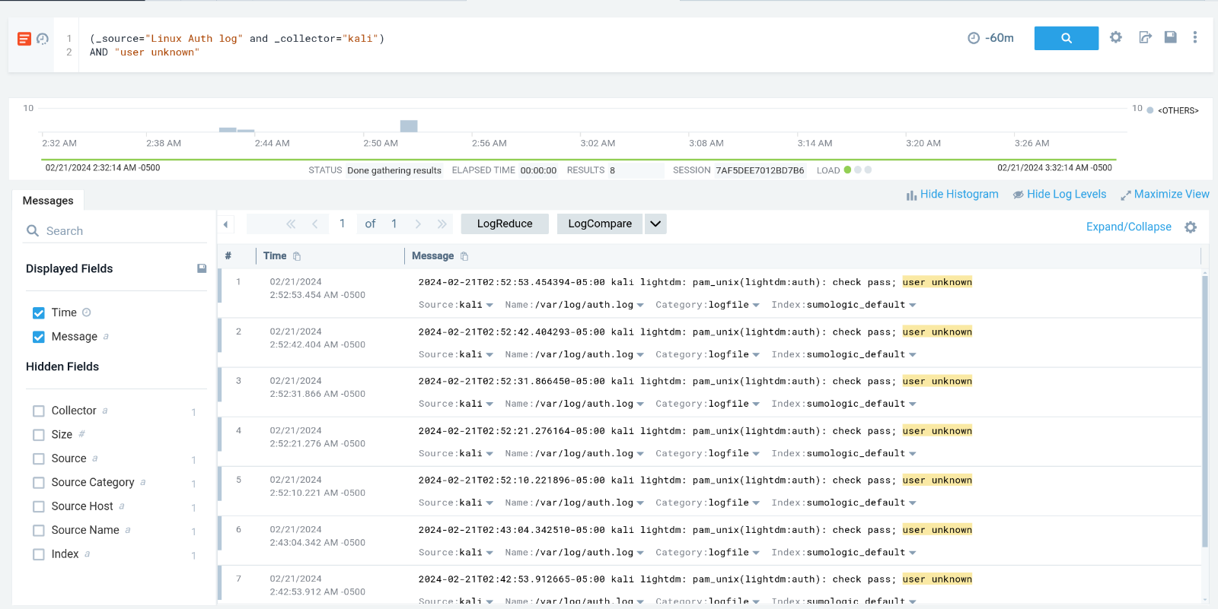

1. The number of valid users

